🔷 1. Architecture Overview
Source → Informatica IICS → Data Warehouse → KPI Reports
Flow:
Extract telecom CDR data from CSV sources
Transform using Informatica transformations
Load into Data Warehouse (Fact & Dimension tables)
Generate KPI reports
🔷 2. Source Systems
CDR_Raw_Telecom (Call data)
Customer_master_Telecom
Tower_master_Telecom
Date Dimension
🔷 3. Data Warehouse Design
Fact Table:
FACT_CALLS (Call details: duration, revenue, type)
Dimension Table:
DIM_CUSTOMER (Handled using SCD Type 2)
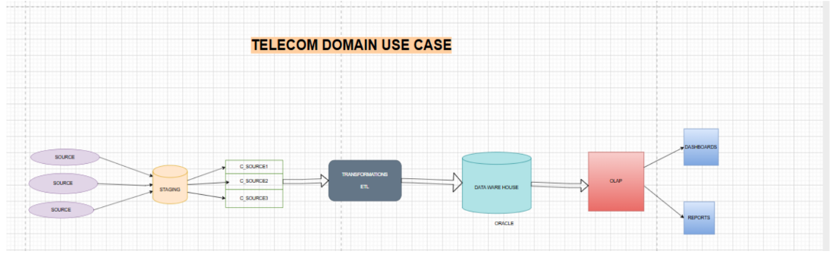
🔷 4. IMPLEMENTATION
✅ 4.1 SCD TYPE 2 – DIM_CUSTOMER LOAD
Objective:
Track historical changes in customer data.
Transformations Used:
Source → Lookup → Expression → Router → Target
Logic Implemented:
🔹 Expression Transformation:
Handle NULL values
Create flags:
IS_NEW → New customer
IS_CHANGED → Existing but modified
🔹 Router Transformation:
GRP_NEW → New records
GRP_CHANGED → Updated records
🔹 SCD2 Handling:
Old record → Expire (set END_DATE)
New record → Insert with:
START_DATE = SYSDATE
END_DATE = 31-12-9999
IS_ACTIVE = 1
Key Fields:
CUSTOMER_KEY (Surrogate Key)
START_DATE
END_DATE
IS_ACTIVE
Result:
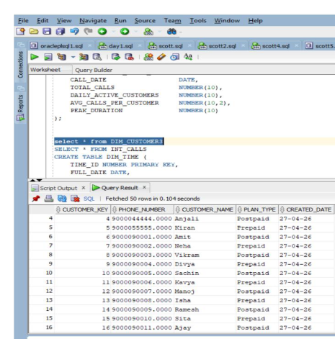

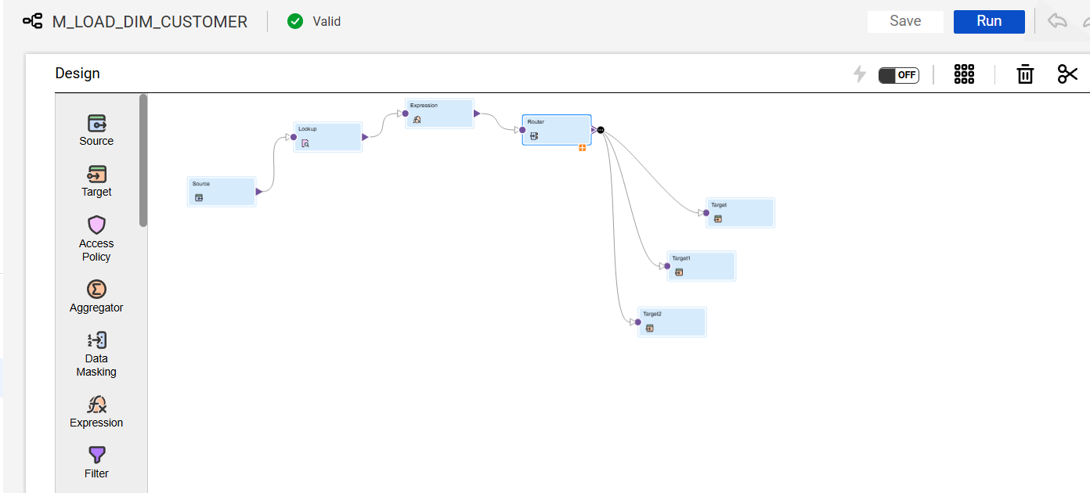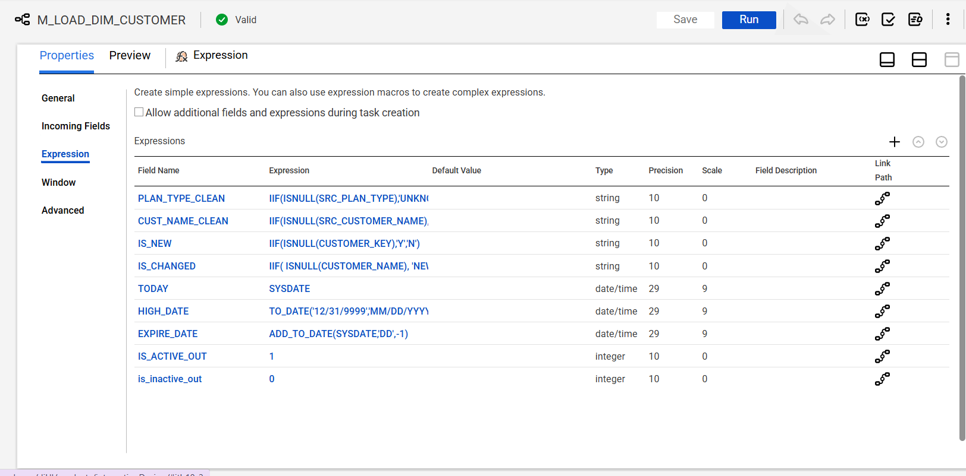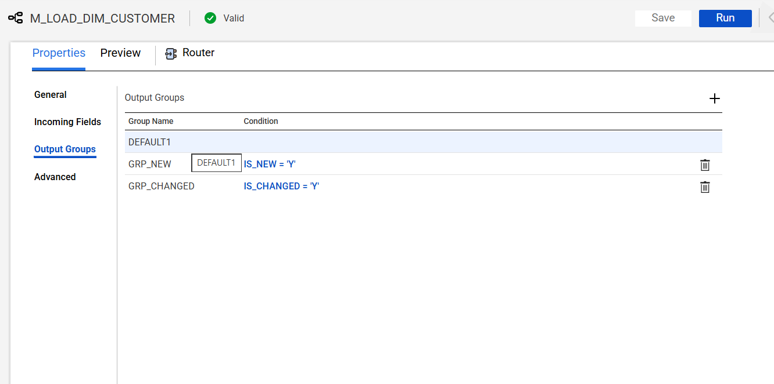
✔ Historical tracking maintained
✔ No data loss
✔ Supports time-based analysis
✅ 4.3 KPI3 IMPLEMENTATION (IMPORTANT)
🔴 Key Concept:
Aggregator is mandatory
Why?
Expression → works row by row
Aggregator → combines multiple rows into one
❌ WITHOUT Aggregator:
18 rows → 18 outputs
No SUM, COUNT possible
Wrong KPI result
✅ WITH Aggregator:
18 rows → 1 row
Correct metrics:
Aggregator Logic:
COUNT(CALL_ID) → INTL_COUNT
SUM(DURATION) → TOTAL_DURATION
SUM(REVENUE) → TOTAL_REVENUE
AVG(REVENUE) → AVG_REVENUE
Expression After Aggregator:
Rename fields
Calculate:
Revenue per call
Percentage of international calls
✔ Final KPI3 Output (Sample)

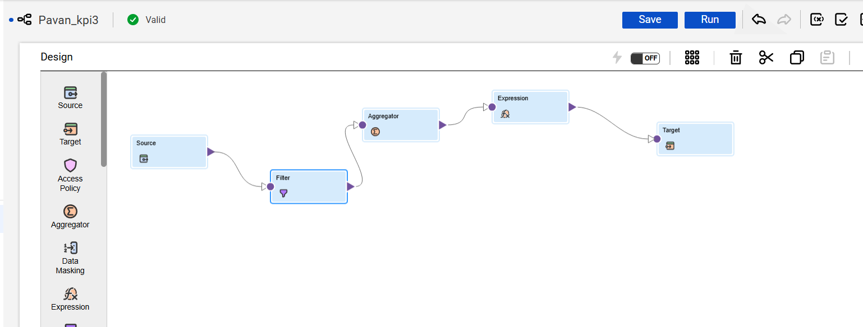

INTL_CALL_COUNT TOTAL_DURATION TOTAL_REVENUE AVG_REVENUE
18 14770 5200 288.89
🔷 5. Transformations Used
Source
Filter (IS_INTERNATIONAL = 1)
Aggregator
Expression
Lookup
Router
🔷 6. Workflow & Execution
Mapping validated and executed successfully
Data loaded into target tables
KPI reports generated
🔷 7. Error Handling
Filter invalid records
Handle NULL values in Expression
Maintain data consistency

